**GYNO-BOT**

**Problem statement:**

Every woman and girl go through the unpleasant phase called the menstruation period in her life. Many were not aware of taking care of themselves at this time. Few women and girls feel insecure and uncomfortable discussing this with their family or friends.

**Solution:**

Gyno-Bot is a simple chat bot used to provide basic information about menstruation. It was created using various Azure services like Azure bot service (Web app bot), QnA Maker, App service, and Html, hosted on GitHub pages. As many women and girls feel uncomfortable discussing menstruation problems with their family and friends, Gyno-Bot helps them answer all the basic questions about menstruation. It also provides the best caring procedures to follow during the menstruation period.

**Project Description/Explanation:**

The core idea of this project GYNO-BOT is to provide basic information and solutions for frequently asked questions about the menstruation period. In order to create a chat-bot we need a knowledge base which consists all the data for answering the questions asked by the user.

**Usage of QnA Maker:**

I’ve used Azure QnA Maker service to create knowledge base as shown below:

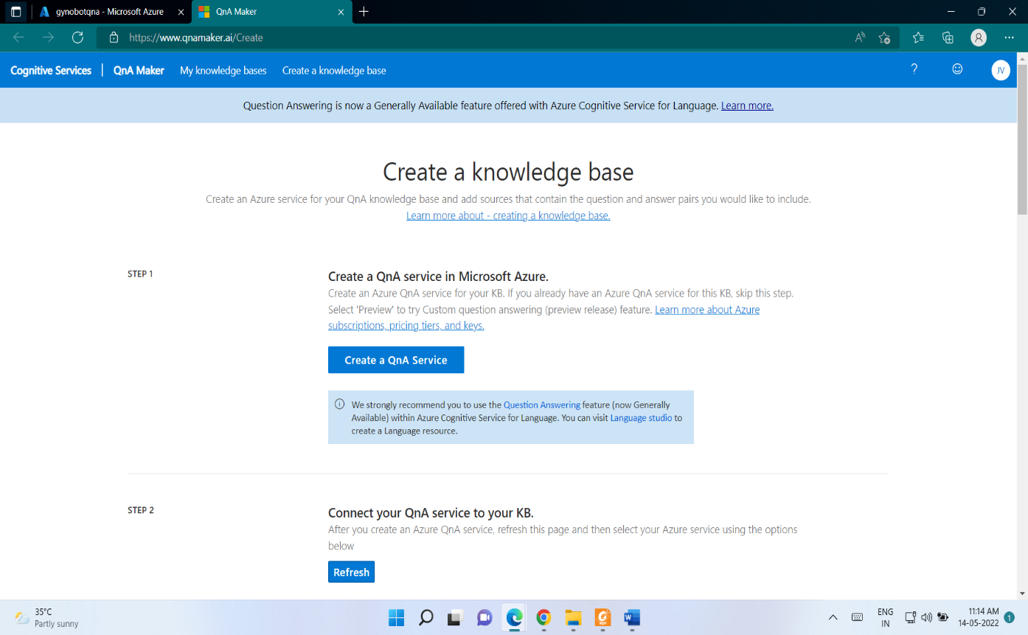

We can either upload a direct URL or upload a specific file from our local. I have collected the best responses from various sources hence I have made a pdf file and uploaded that as a Knowledge Base.

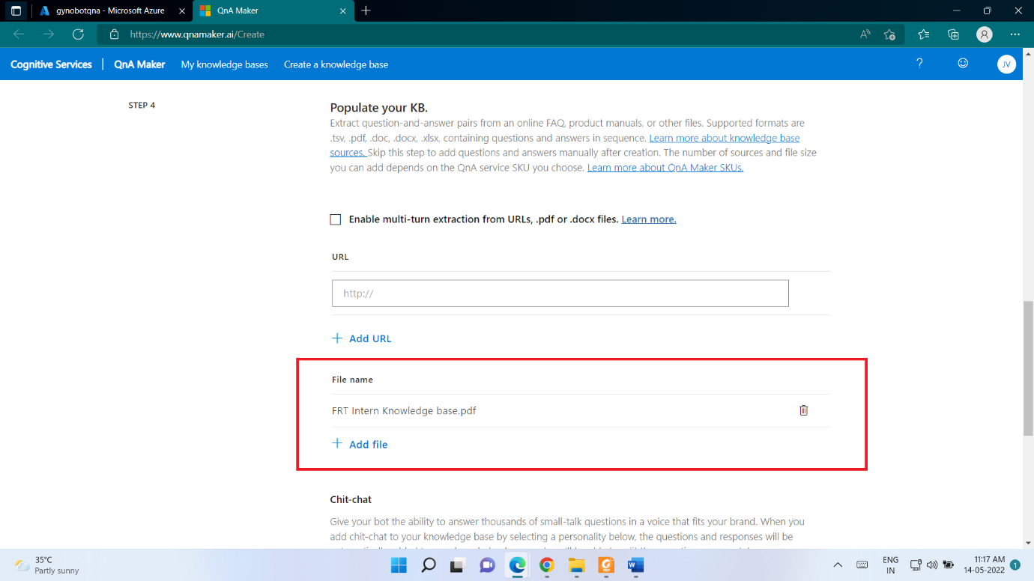

I have uploaded the Knowledge base pdf file in my GitHub repo as well

“<https://github.com/Jaay-vs-Teja/Gyno-Bot>”

We can also add few more questions manually by clicking on Add QnA pair and then publish.

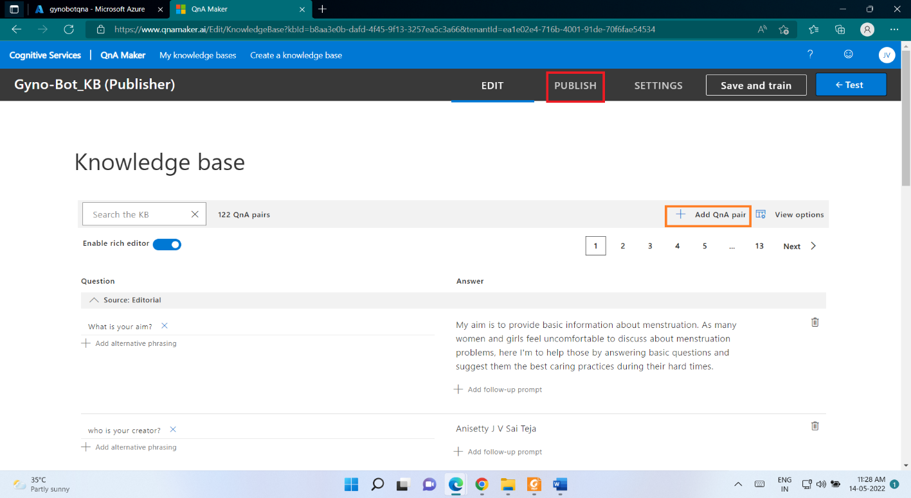

**Usage of AI+machine learning🡪Bot Service (Web app bot):**

After publishing the knowledge base I’ve connected it to a Web app bot using create a bot option. We can also find this Bot service under AI+Machine learning service category. You can see the basic deployment details of the bot in the overview section as below

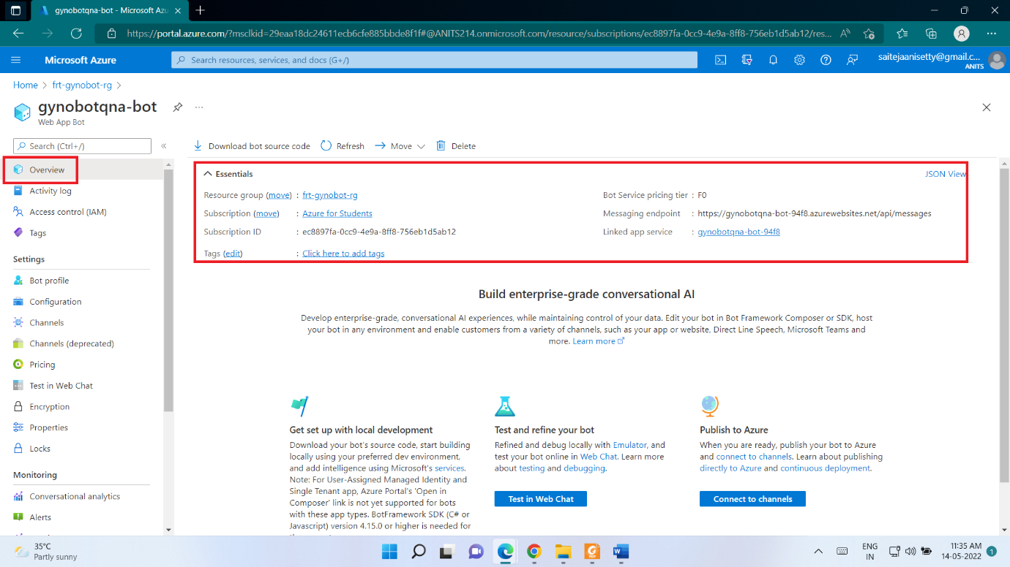

We can use Test in web chat option to test the web app bot. From the channels tab by clicking on Web chat we get bot embed codes which were used to embed our bot onto webpage.

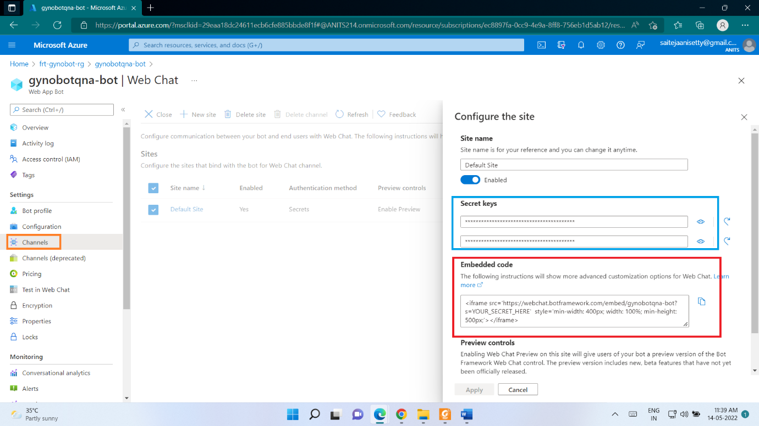

The secret keys were unique and helps to link our service. We should paste the secret keys in the place of YOUR_SECRET_HERE in the embedded code.

**Usage of app service:**

We can find the deployment details like subscription used for Gyno-bot, location, subscription id etc as below. The app service is used to help in hosting our applications to the website.

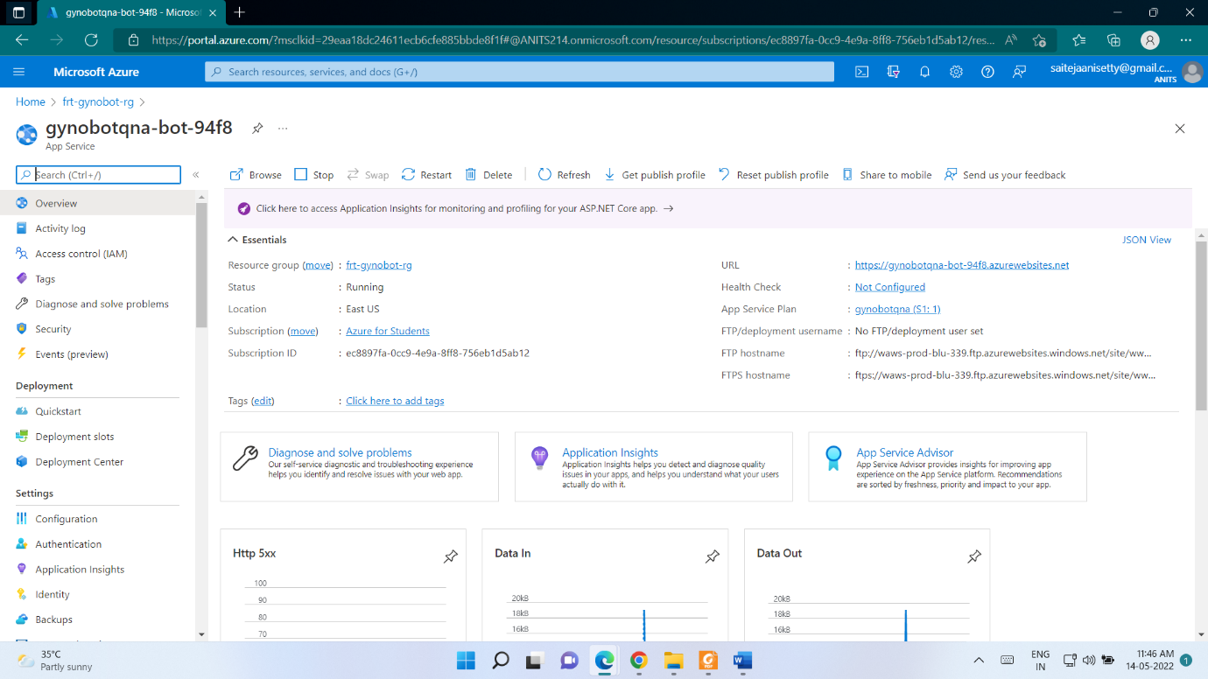

It also represents basic parameters about our app service like Http server errors, Data In, Data Out, Requests and Response time.

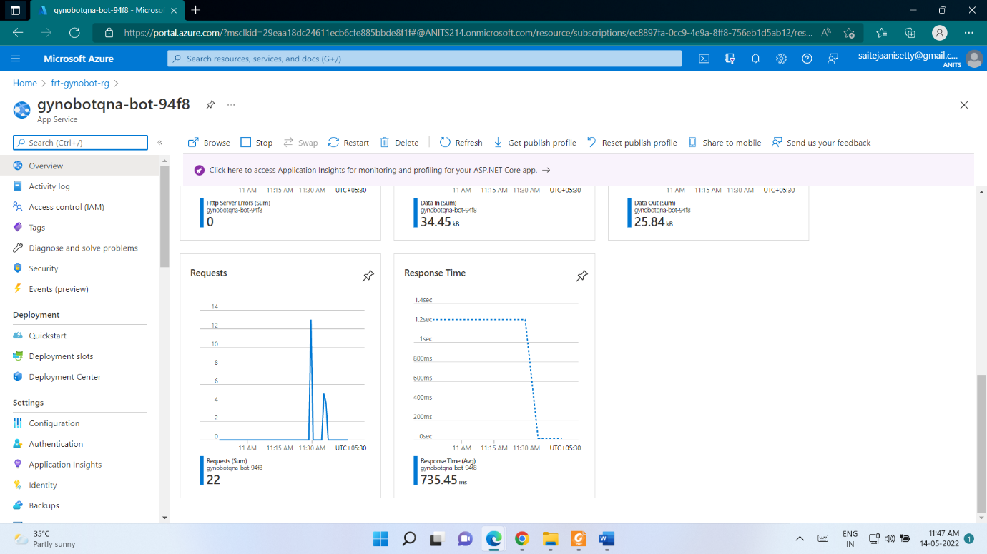

**Usage of HTML:**

I used HTML to build a basic web page to host the Gyno-Bot. You can see the embed code used to integrate the chat bot into website.

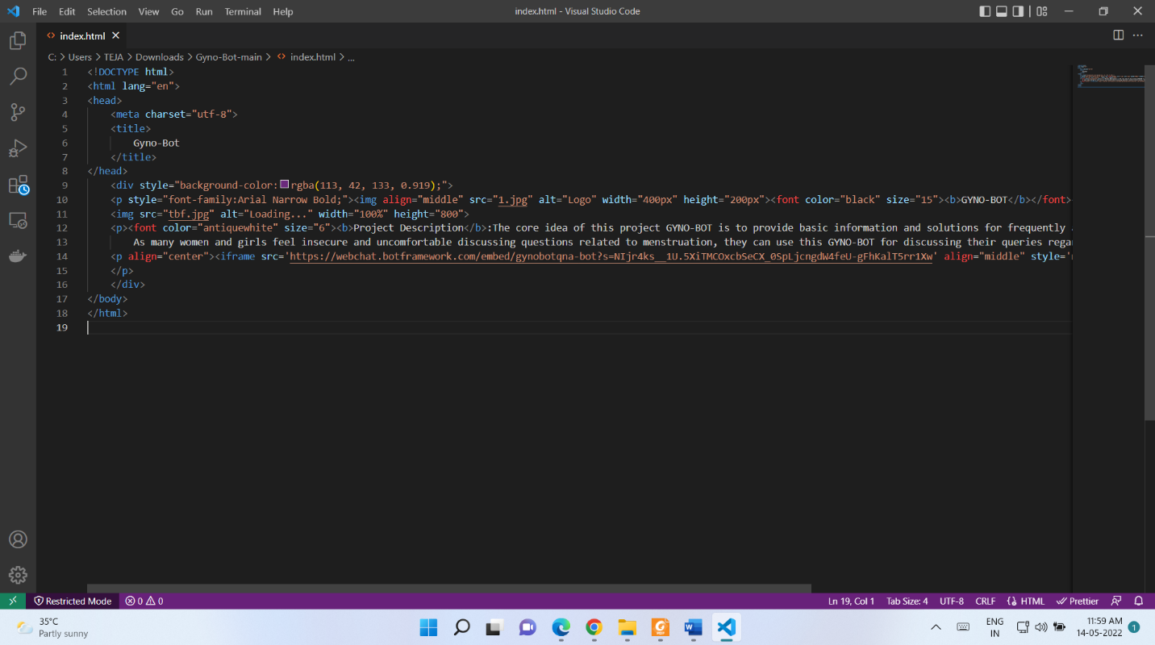

After uploading all the required files, I have hosted the web site using GitHub pages.

**Working URL**: “<https://jaay-vs-teja.github.io/Gyno-Bot/>”

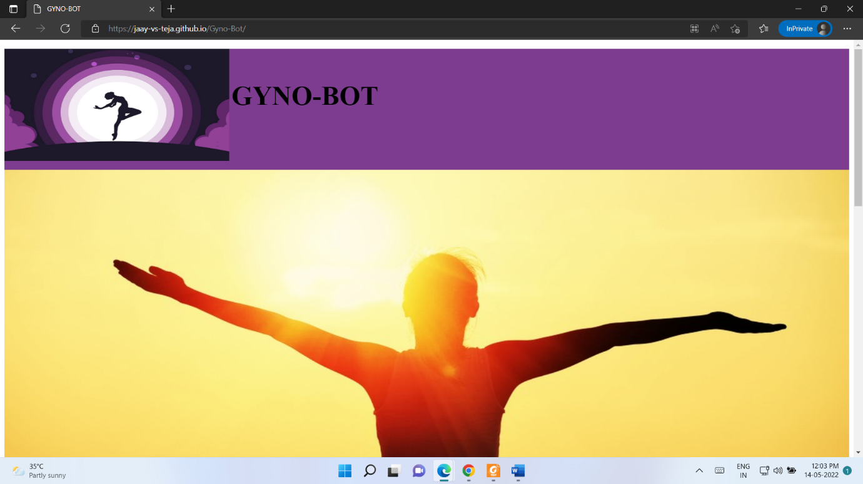

Below is the GYNO-BOT app which is used to provide all the solutions for basic questions on Menstruation.

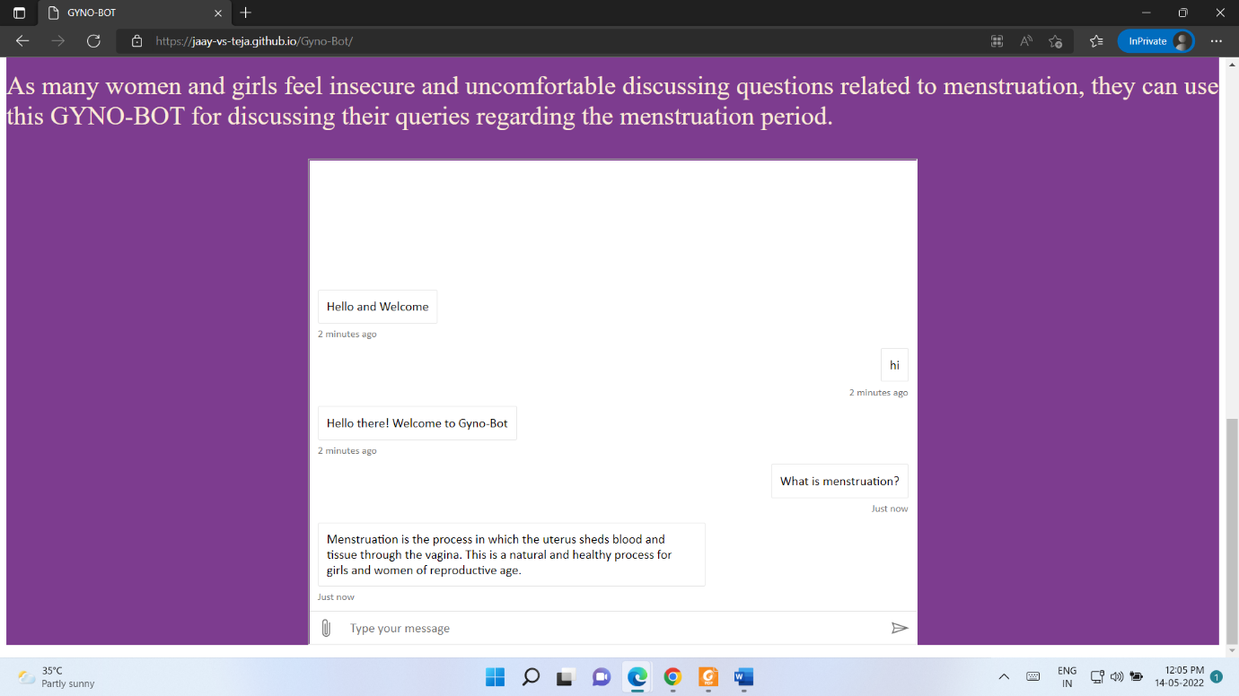

**Further Improvement/Extension ideas:**

* For the future extension we can use Azure AI&ML services for more improved responses from the chat bot.
* Use of Azure cognitive services like Vision, Speech service, Translation service helps in better performance of Gyno-Bot. This helps Gyno-Bot to respond to a speech, answer in any language etc.

**Important links for evaluation:**

**GitHub Repository link:** <https://github.com/Jaay-vs-Teja/Gyno-Bot>

**Working URL of Website created:** <https://jaay-vs-teja.github.io/Gyno-Bot/>

**YouTube Video URL of project Demo:** [**https://youtu.be/ks-_Tcp1hgE**](https://youtu.be/ks-_Tcp1hgE)